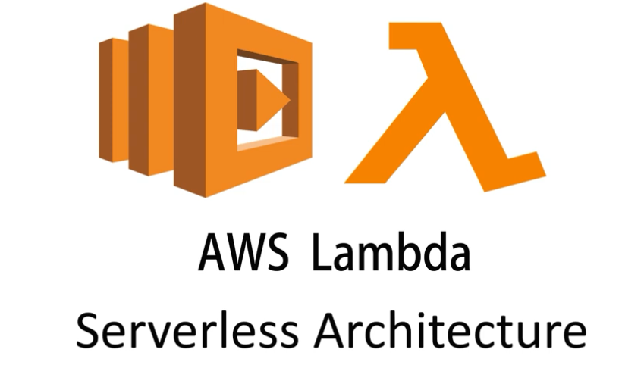

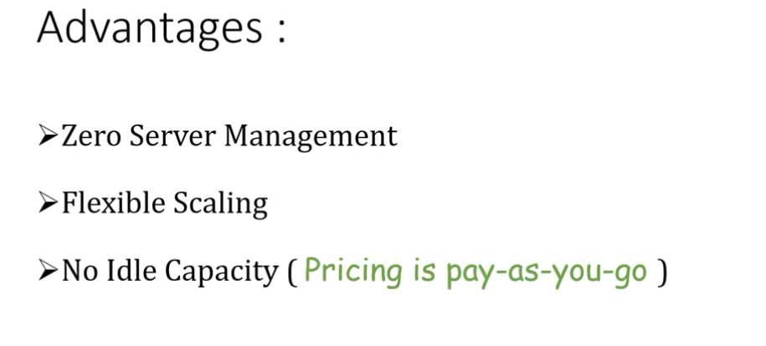
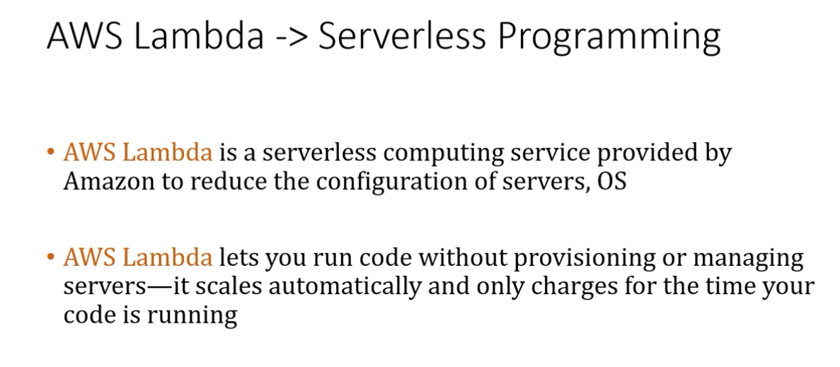
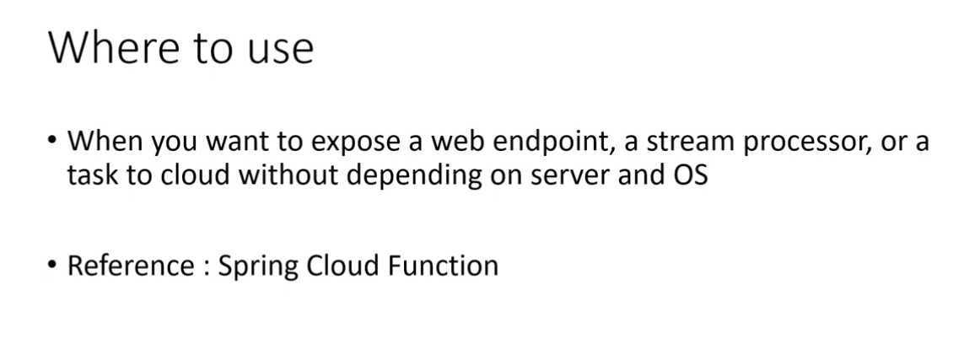
No endpoints. Just created methods which returns java interfaces
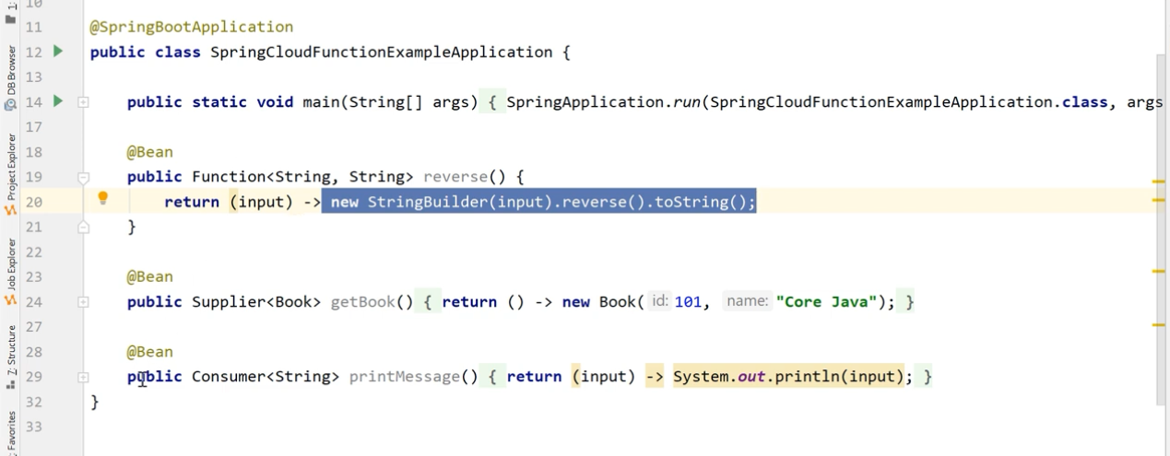
The below example is already developed application – how to test it in local. Even though we have not added web dependency the application still running in the tomcat port 8080. This is because of spring cloud dependency.
This will happen only in local. Provisioning server will not happen in amazon lambda.
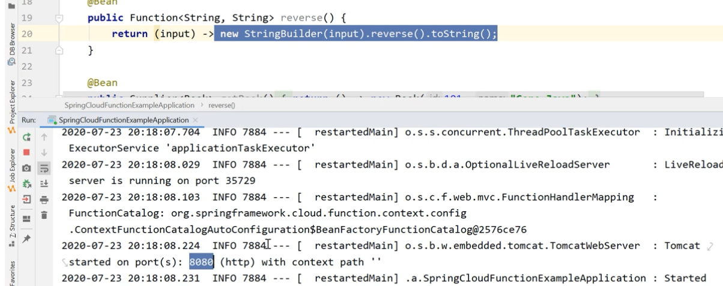
Here method name act as endpoint. Refer the console output.
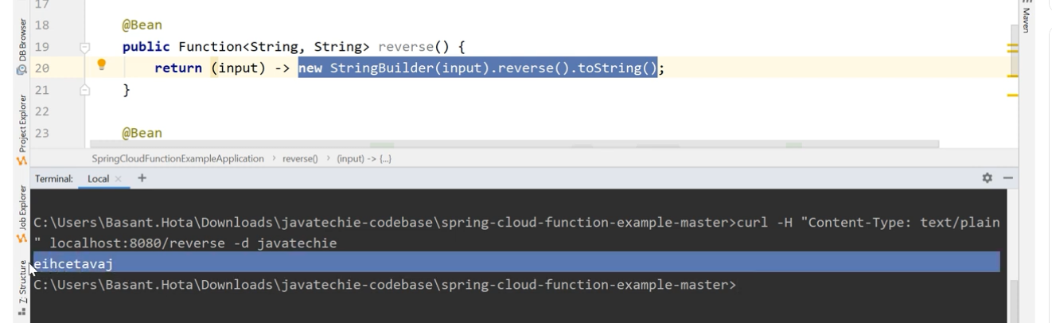
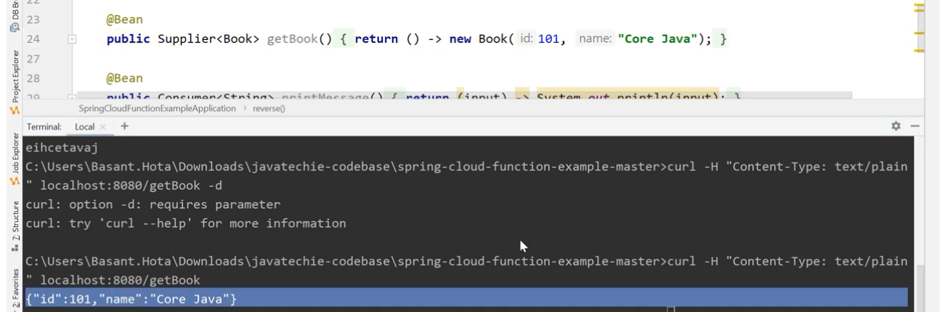
Project dependencies : https://github.com/Java-Techie-jt/springboot-aws-lambda
This is fresh project from scratch

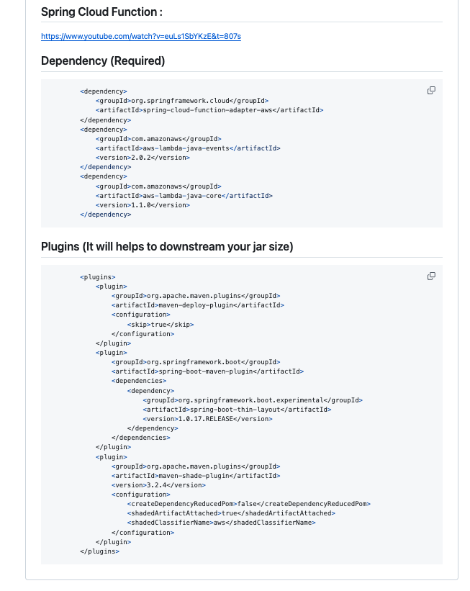
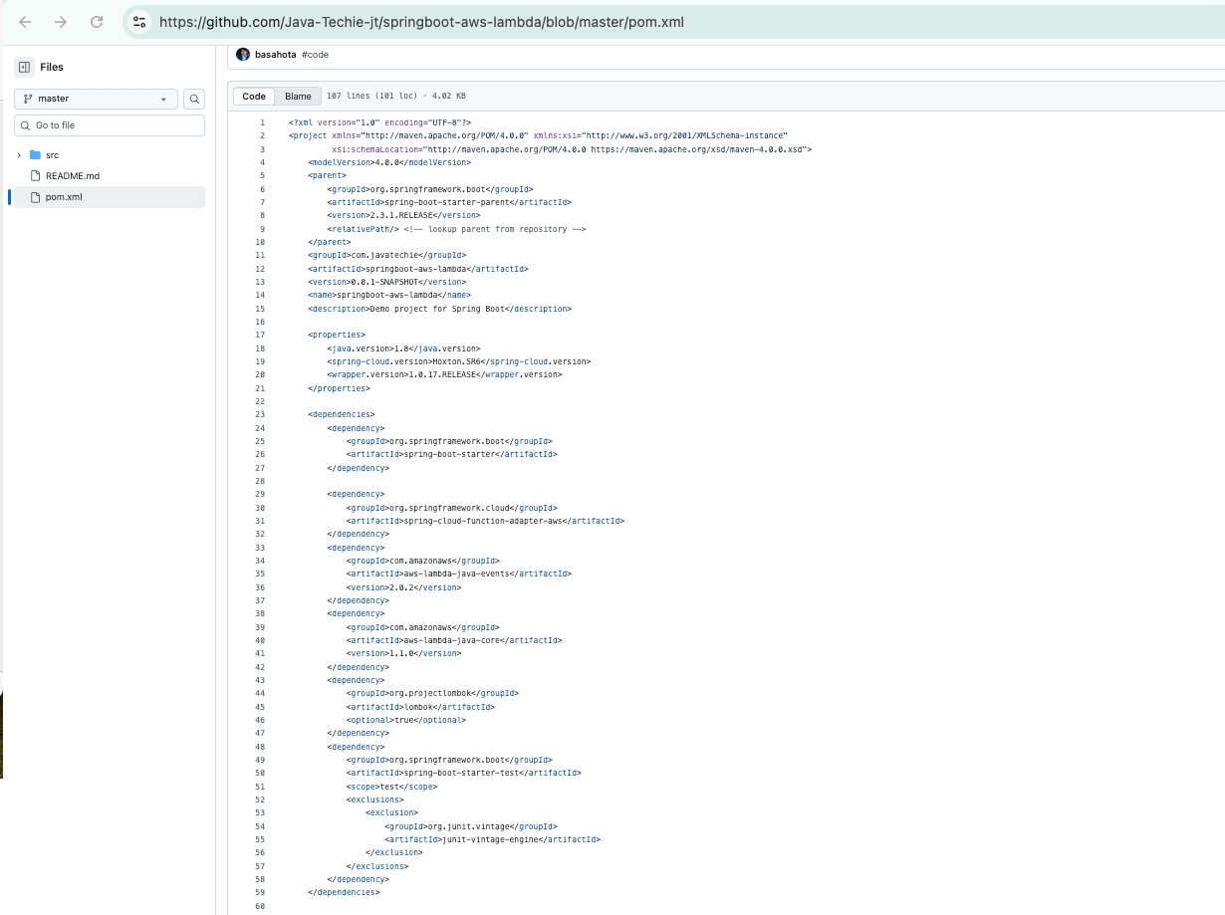
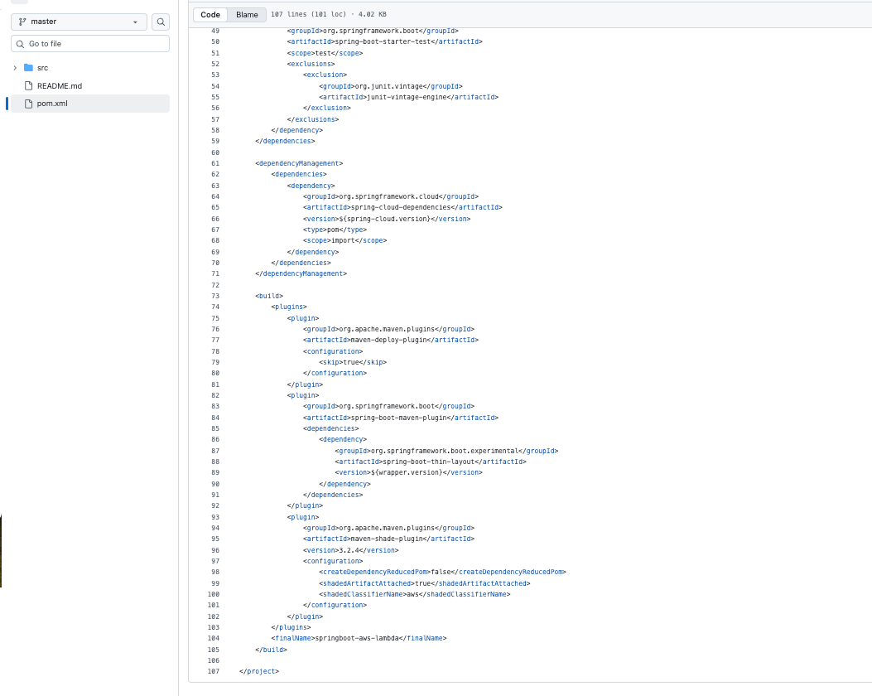

Dummy order repository
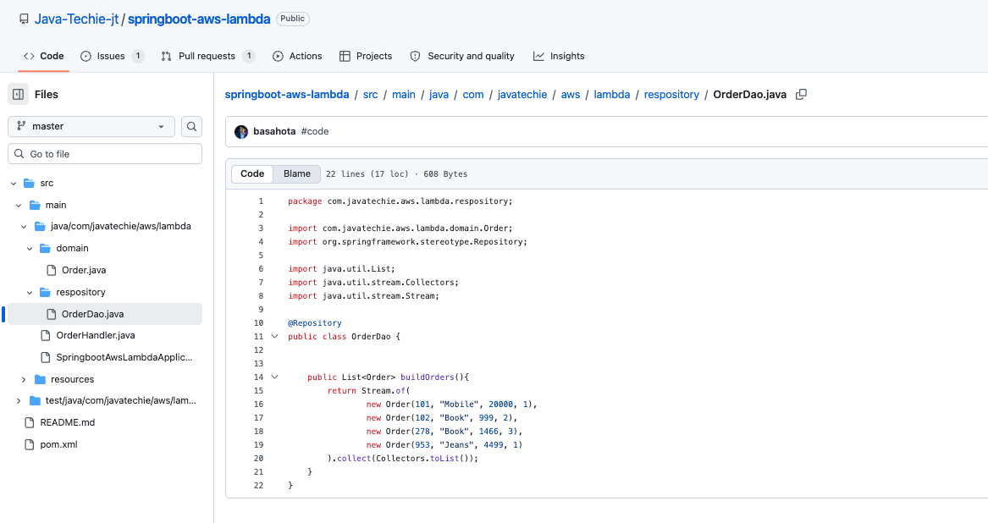
Spring beans with supplier and function interfaces implementation
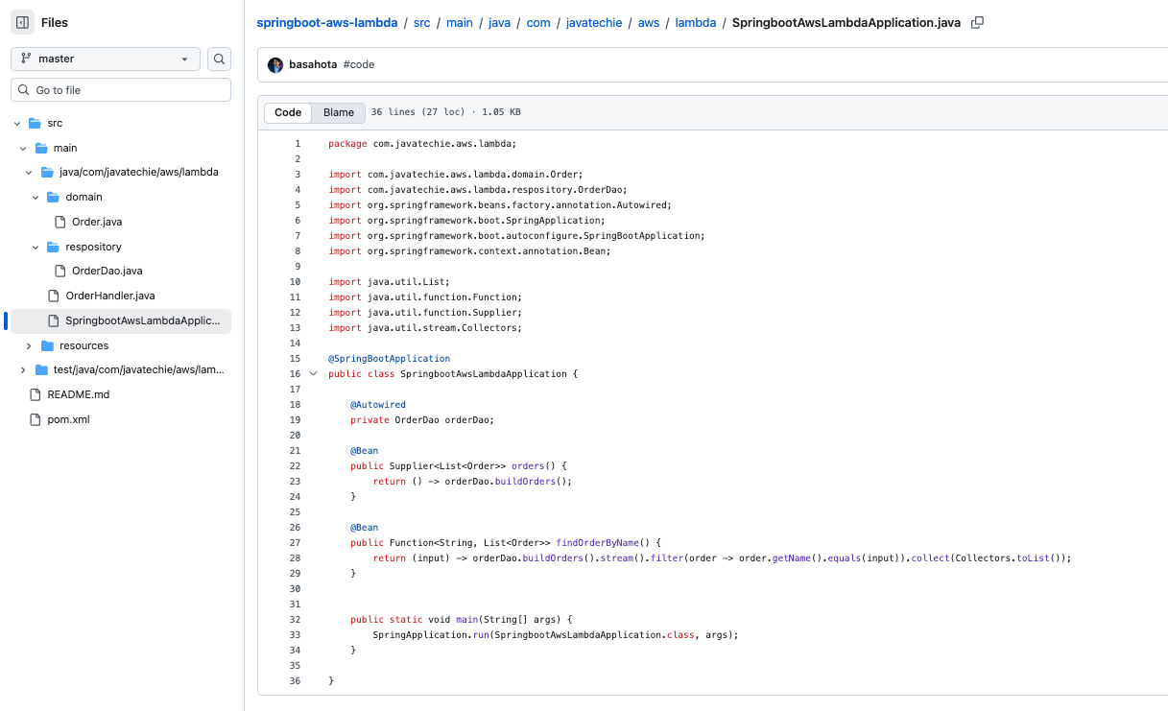

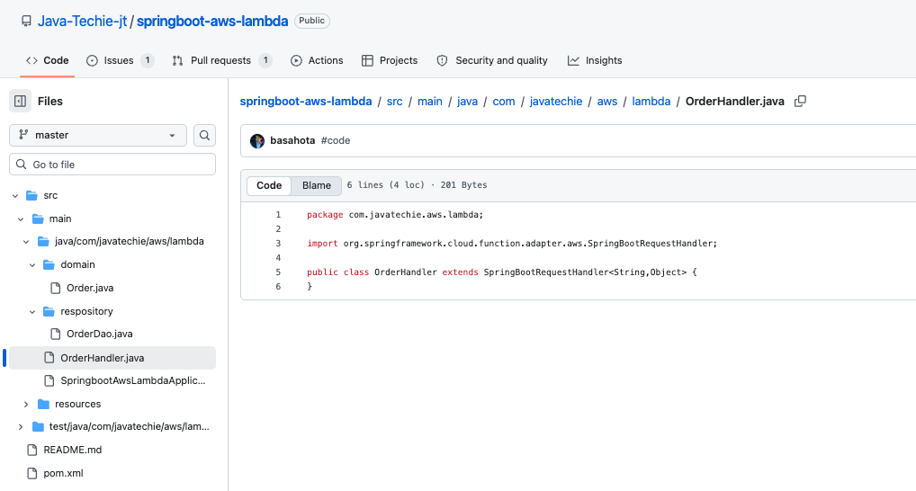
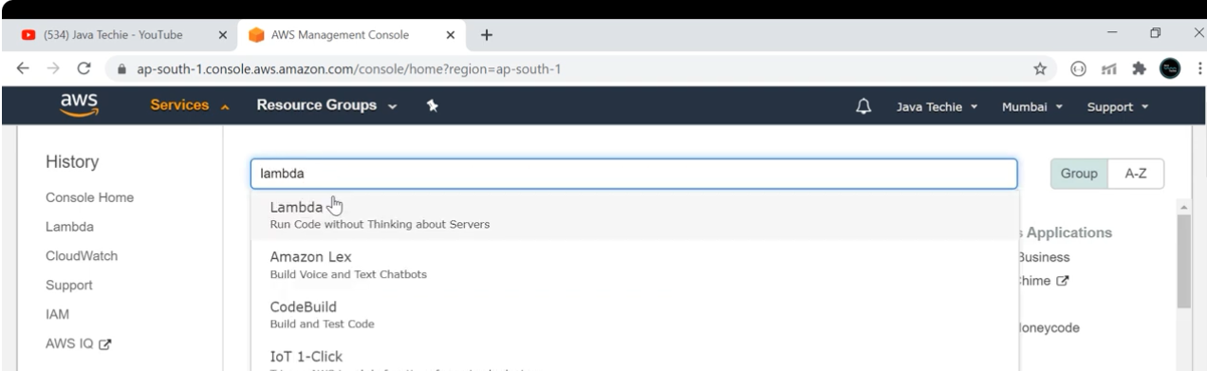
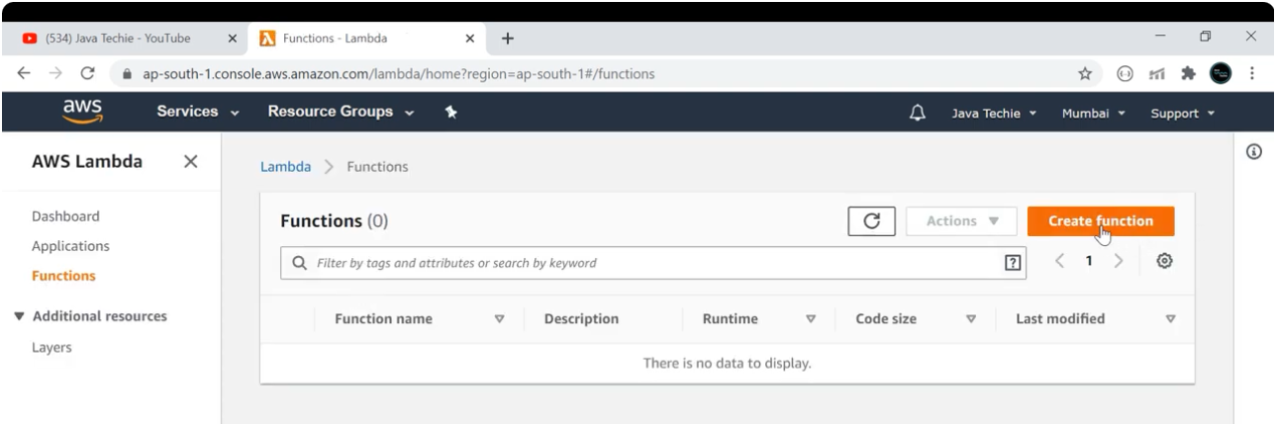

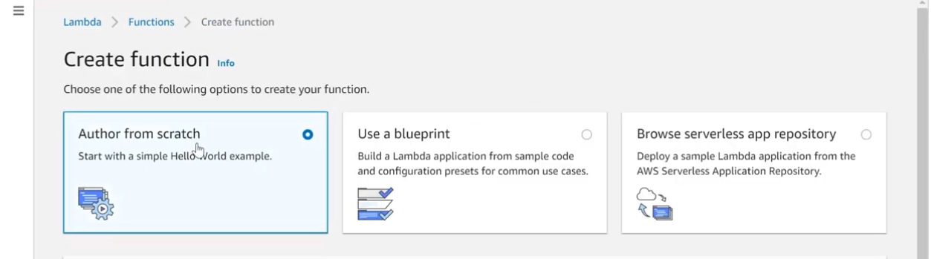
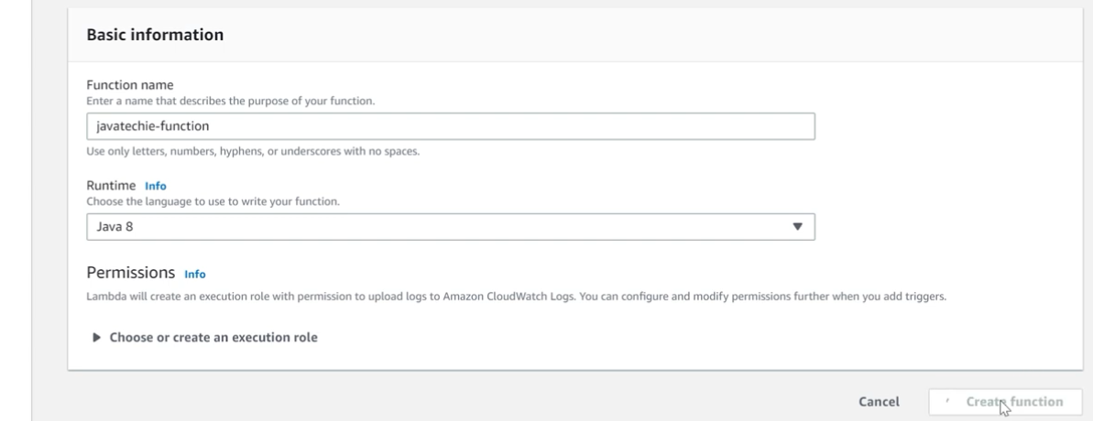
Edit basic settings of this lambda
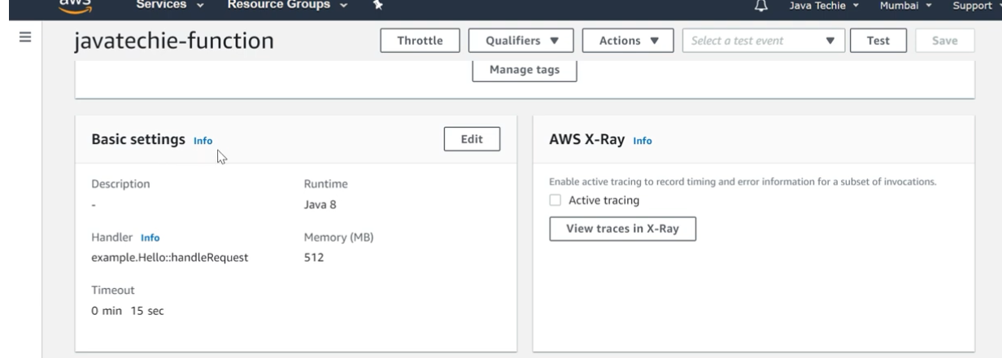

Give this handler name and save.
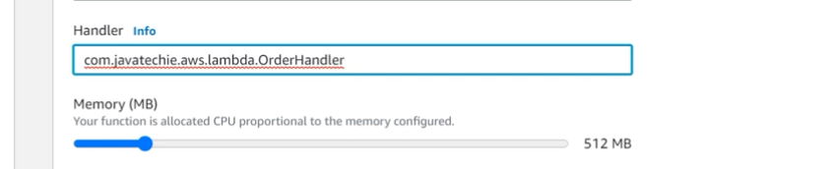
Set environment variable
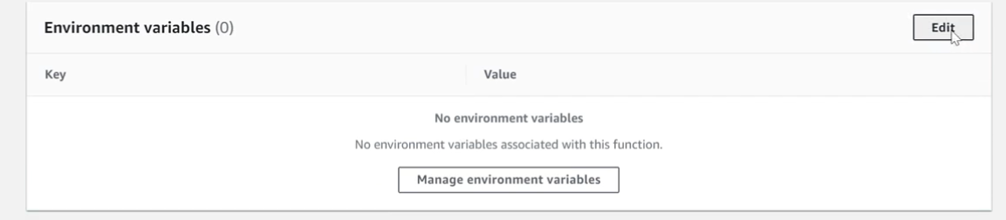
We have to provide method name what has to be executed and save.
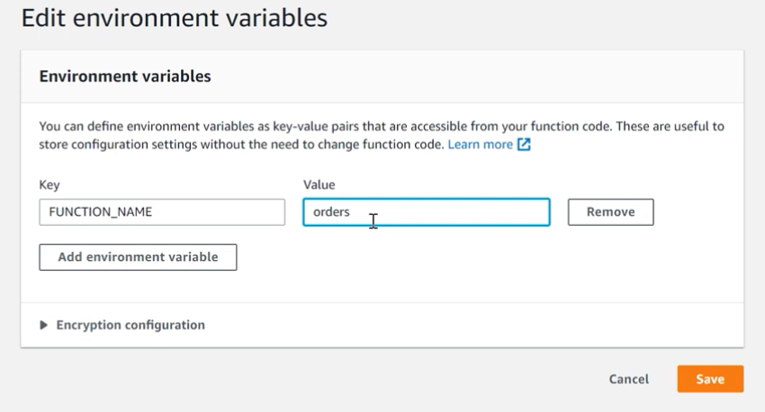

Upload Jar file.
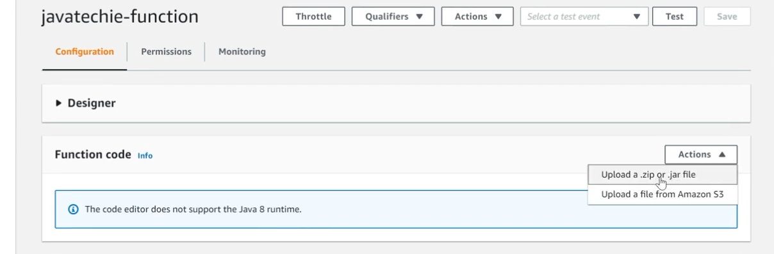
Because we used some plugins it reduces the size of the jar. Just upload the jar
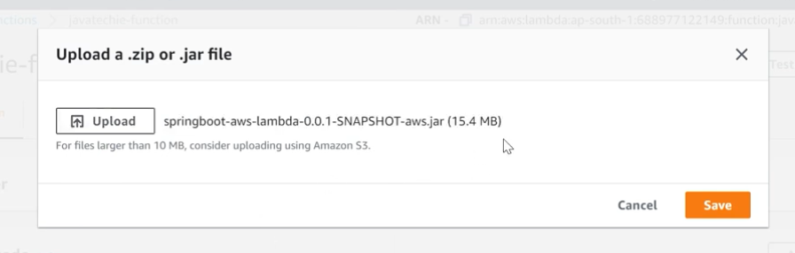

It will start the run without server
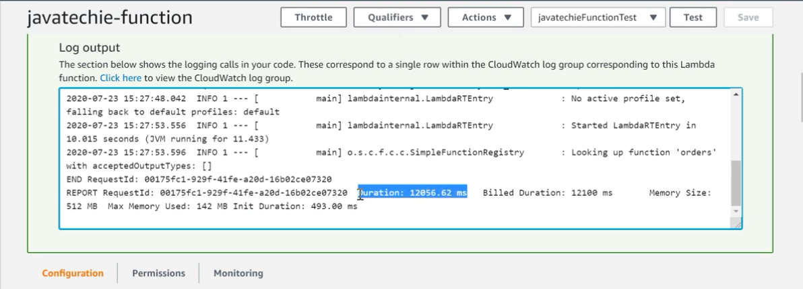

Just test it like this
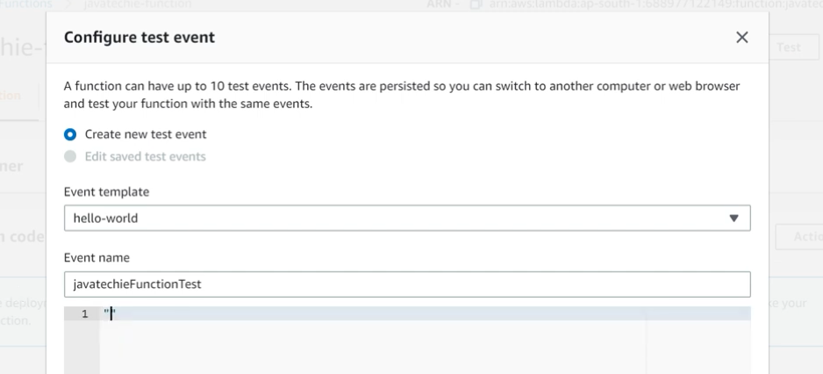
It will return results like this
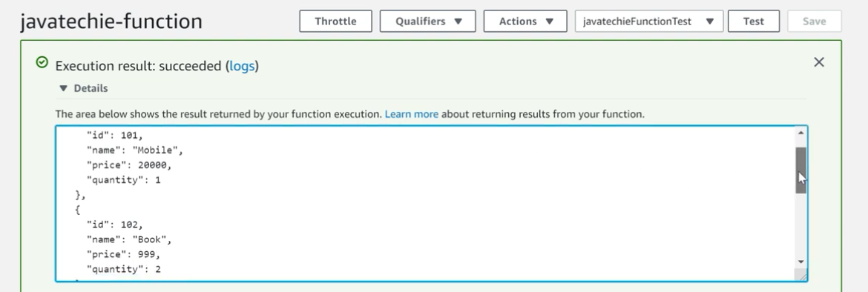
Now execute other interface by changing environment variable
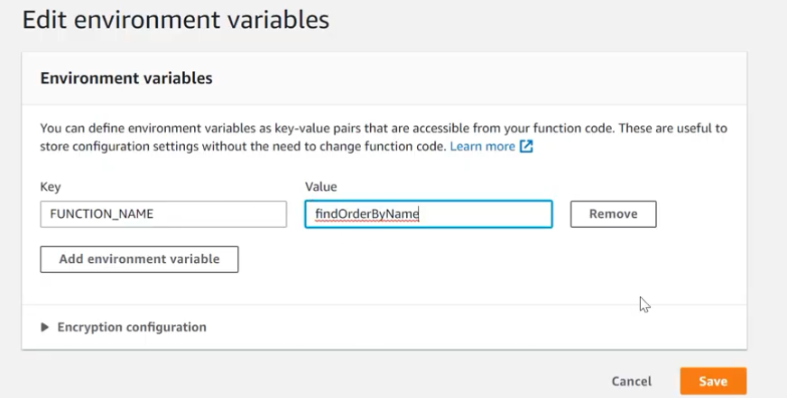
Test it

